Week 3 Internship Report
Title– LTV Prediction & FastAPI Development

Objective
Develop a Customer Lifetime Value (LTV) prediction system using regression models and deploy it through a FastAPI web service capable of single and batch customer predictions.

Tasks Completed
Day 1 – LTV Dataset Preparation
- Loaded Telco Customer Churn dataset.
- Removed missing values.
- Created a new Lifetime Value (LTV) column using:
LTV = MonthlyCharges × Tenure
- Generated and saved the processed dataset as ltv_dataset.csv.
- Performed dataset inspection and statistical summary.
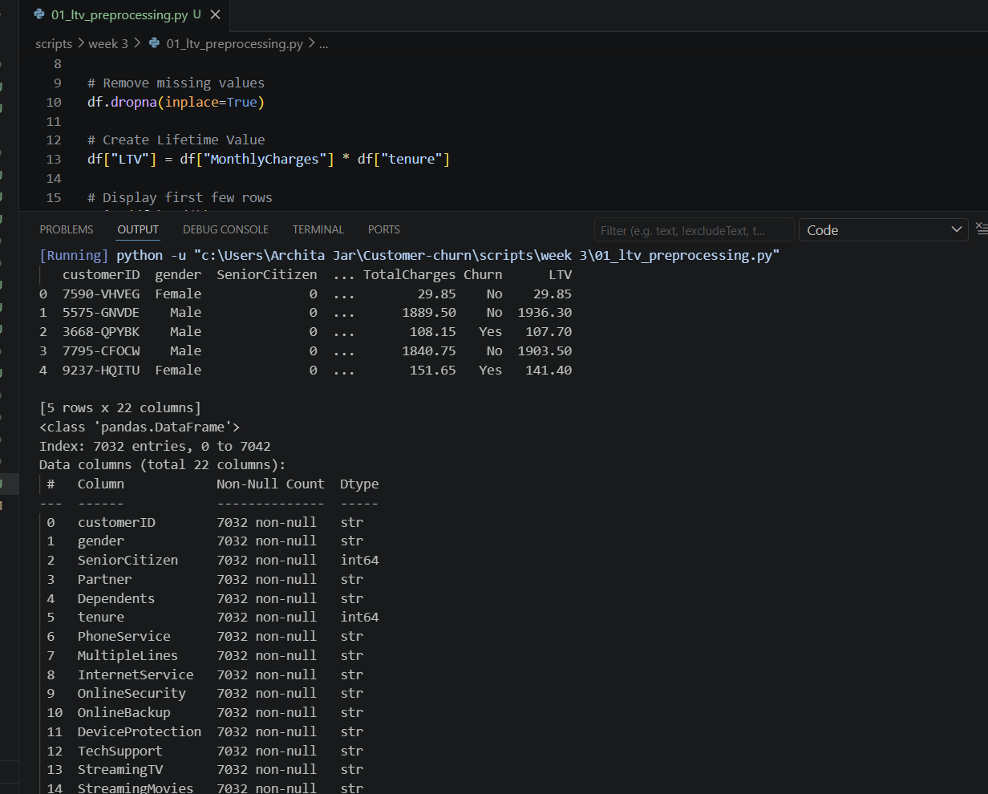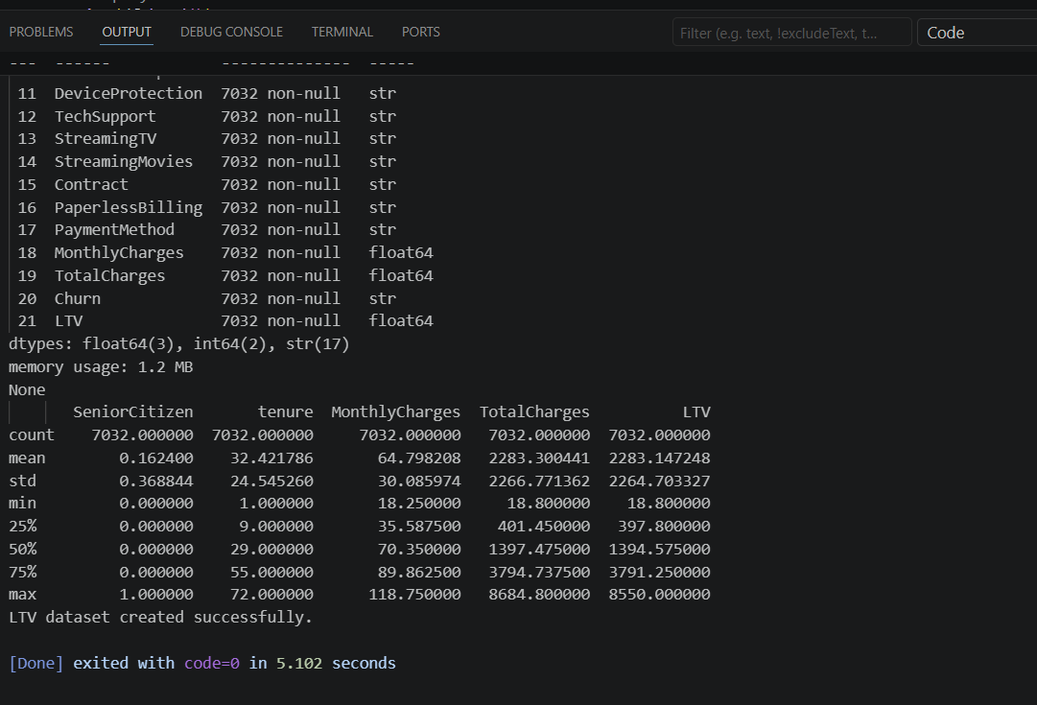
Figure 1: LTV Dataset Preprocessing and Feature Creation

Day 2 – Regression Model Development
- Loaded the LTV dataset.
- Encoded categorical features using LabelEncoder.
- Split dataset into training and testing sets.
- Trained:
  - Linear Regression
  - Random Forest Regressor
- Evaluated both models using:
  - Mean Absolute Error (MAE)
  - Mean Squared Error (MSE)
  - Root Mean Squared Error (RMSE)
  - R² Score
- Saved trained models using Joblib.
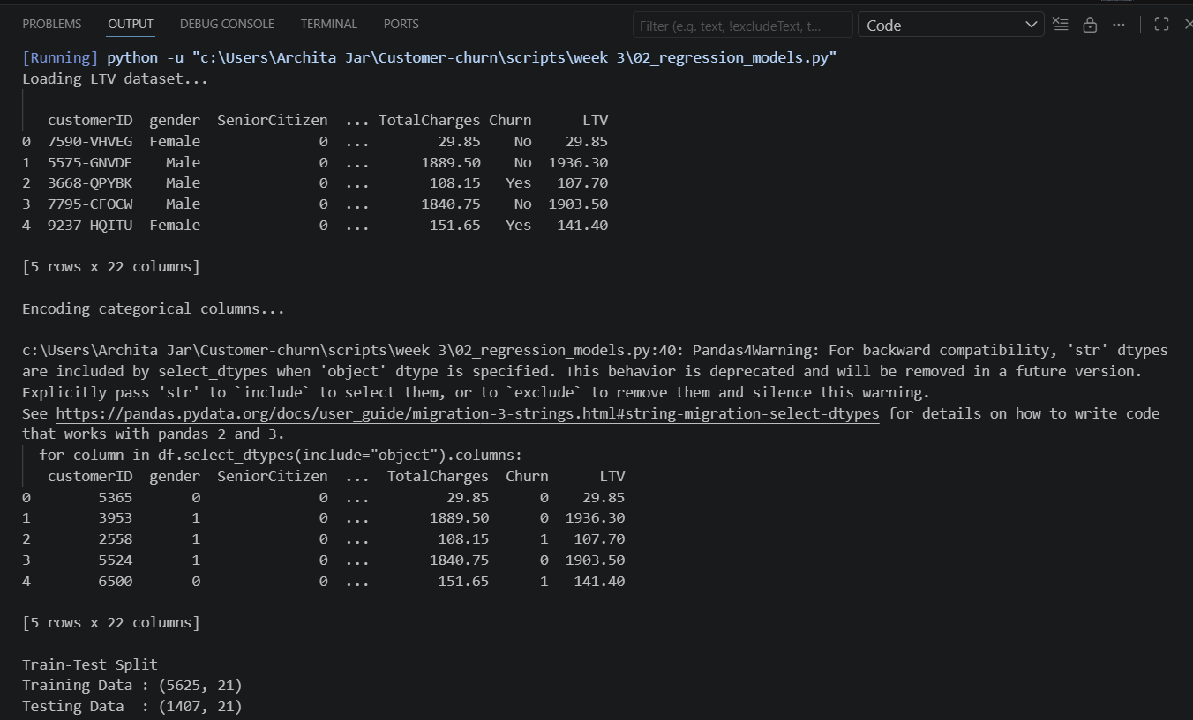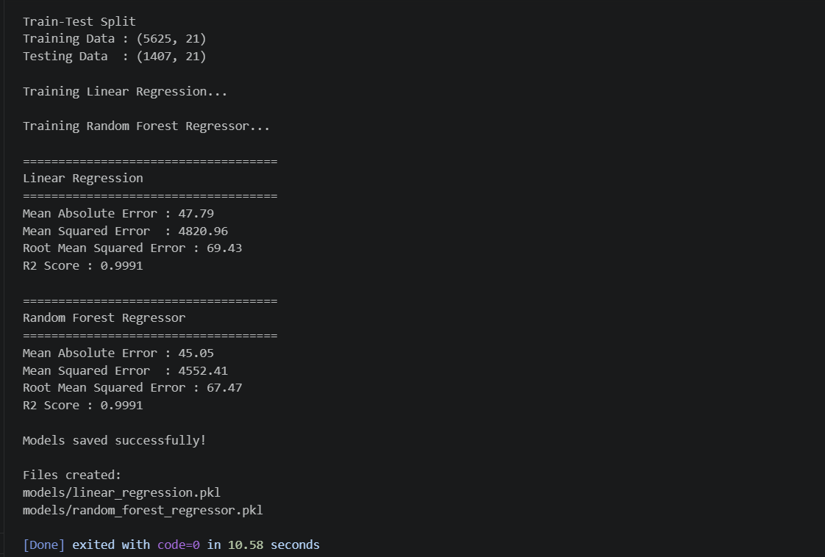
Figure 2: Regression Model Training and Performance Evaluation

Day 3 – FastAPI Development
Developed a RESTful API using FastAPI.
Implemented:
- Home endpoint (GET /)
- Single prediction endpoint (GET /predict)
- Batch prediction endpoint (POST /batch_predict)
Successfully tested all API endpoints using Swagger UI.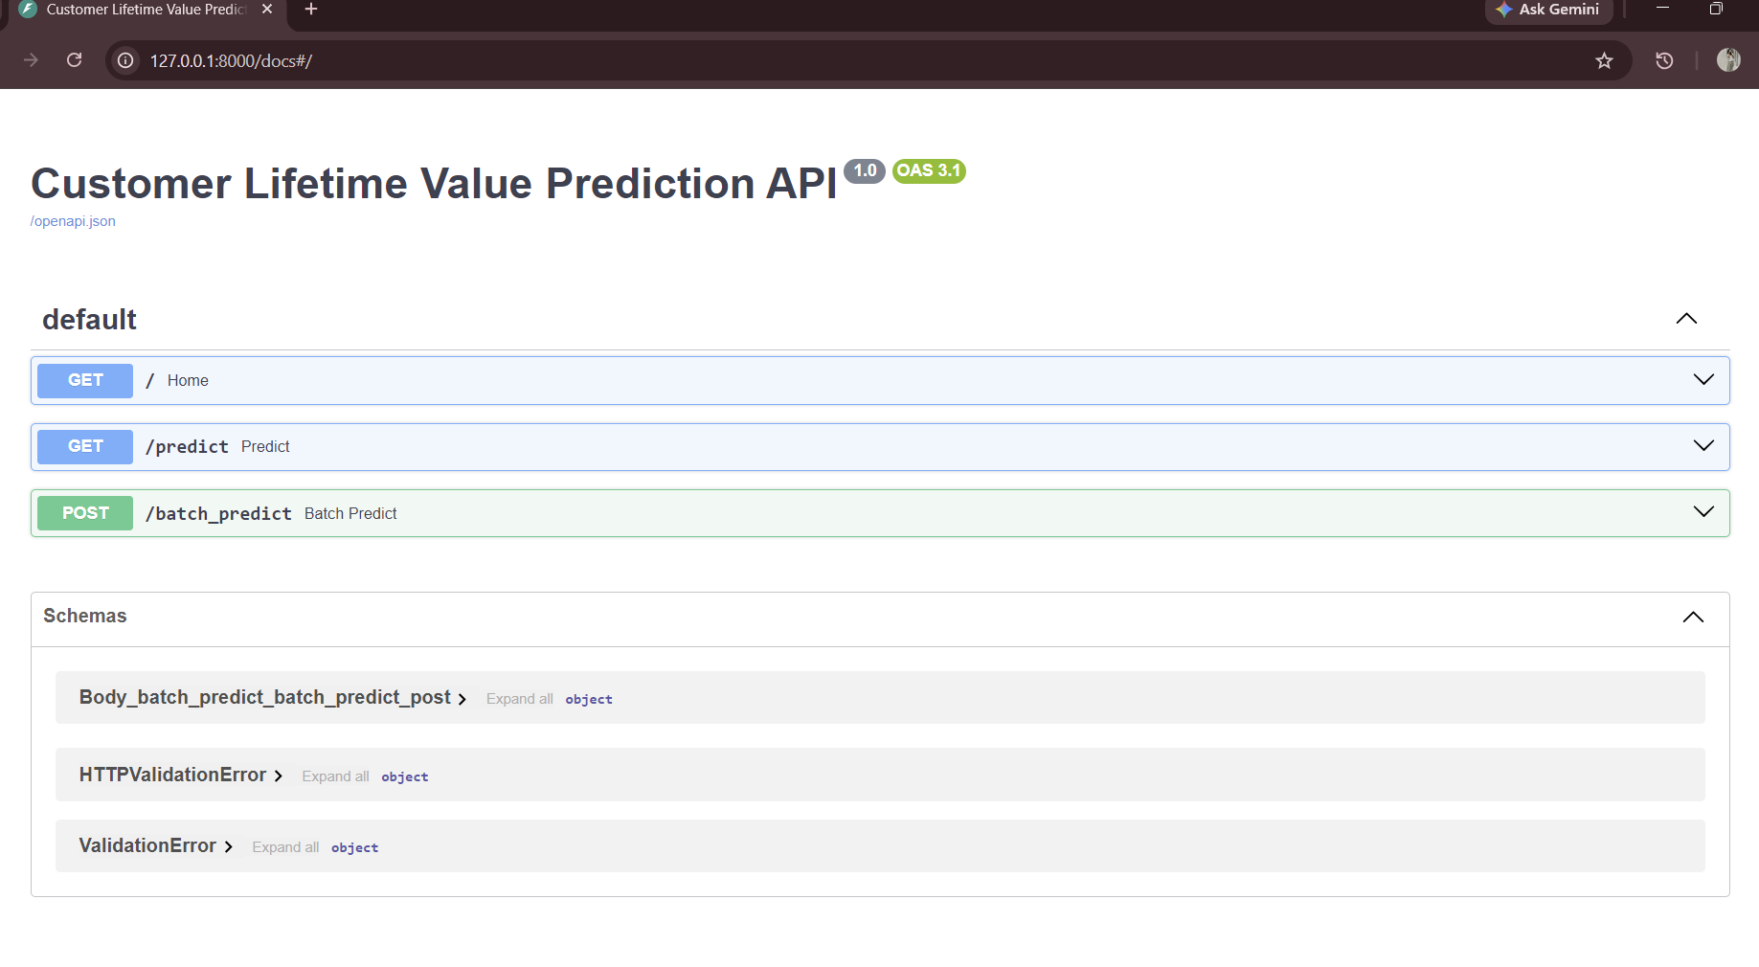
Figure 3: FastAPI Swagger Interface
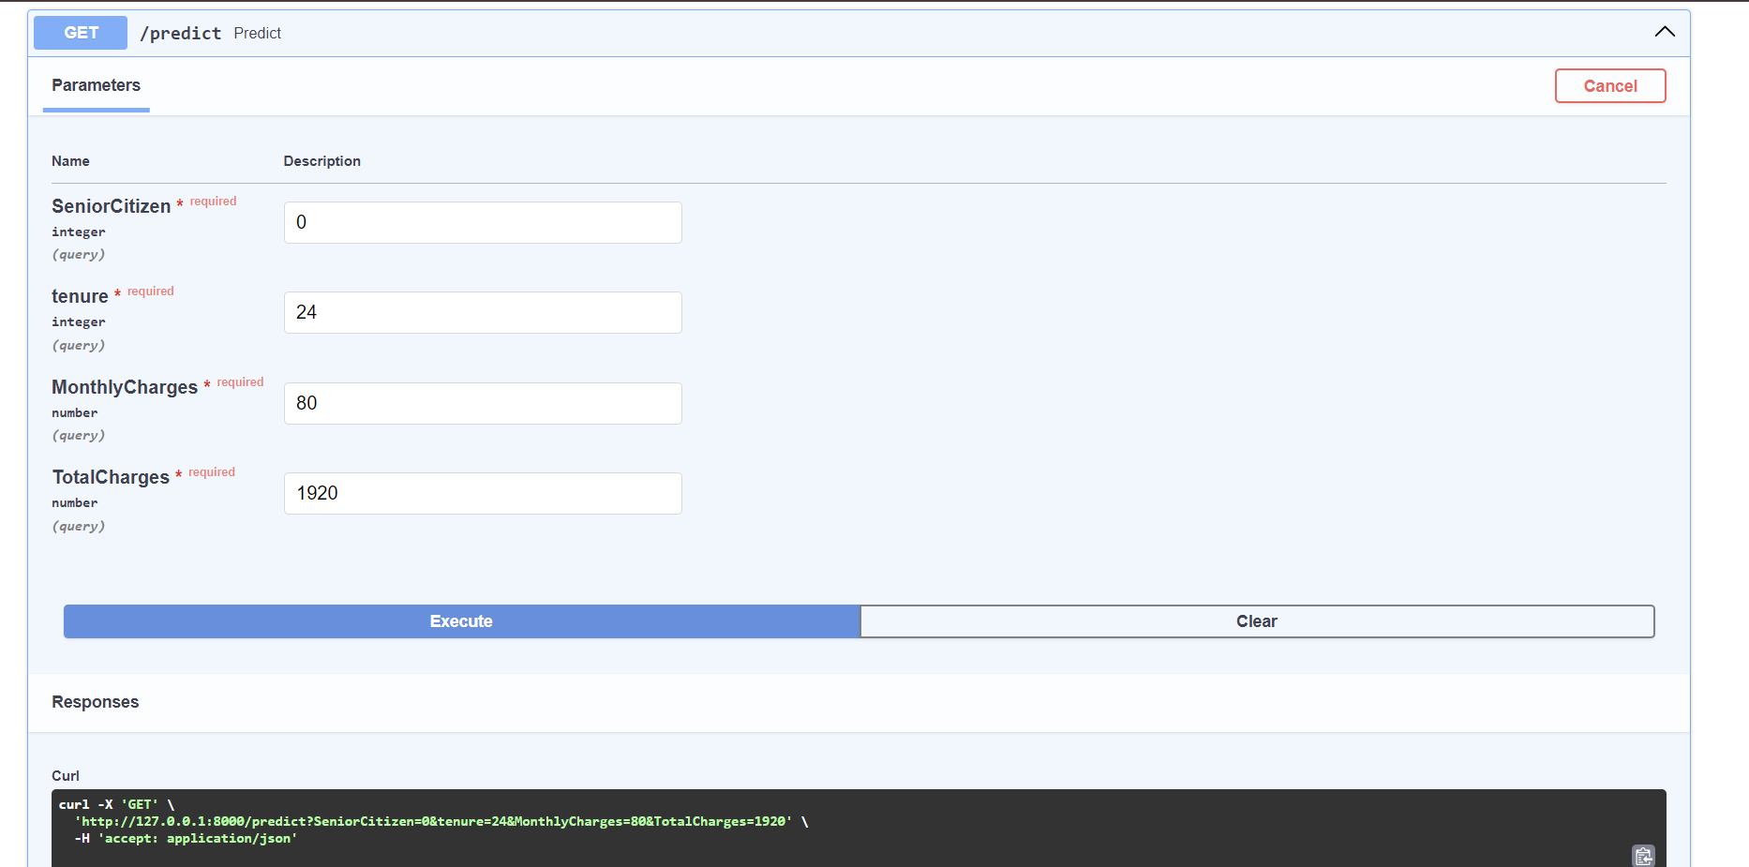
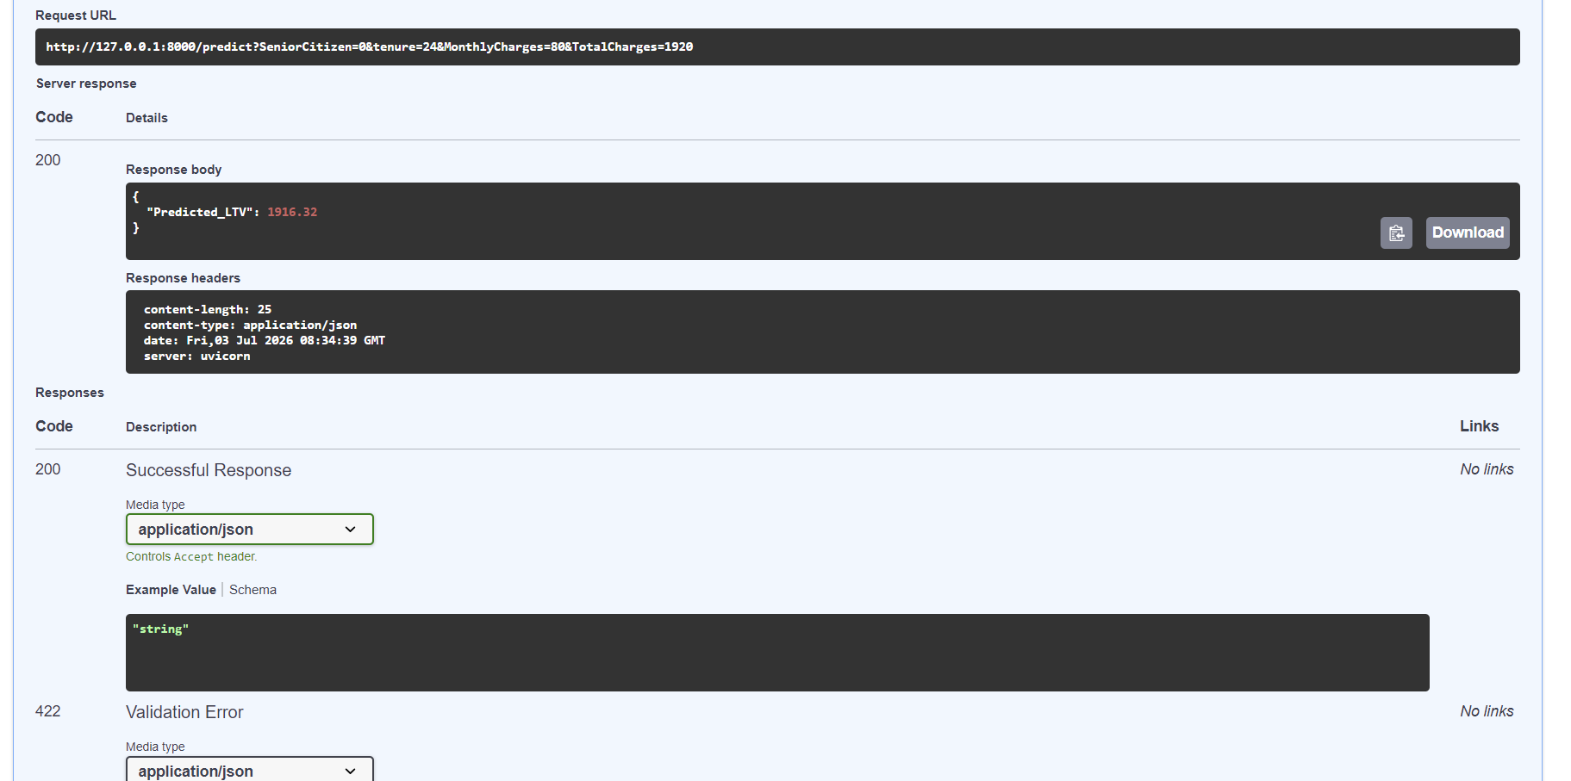
Figure 4: Single Customer LTV Prediction using API
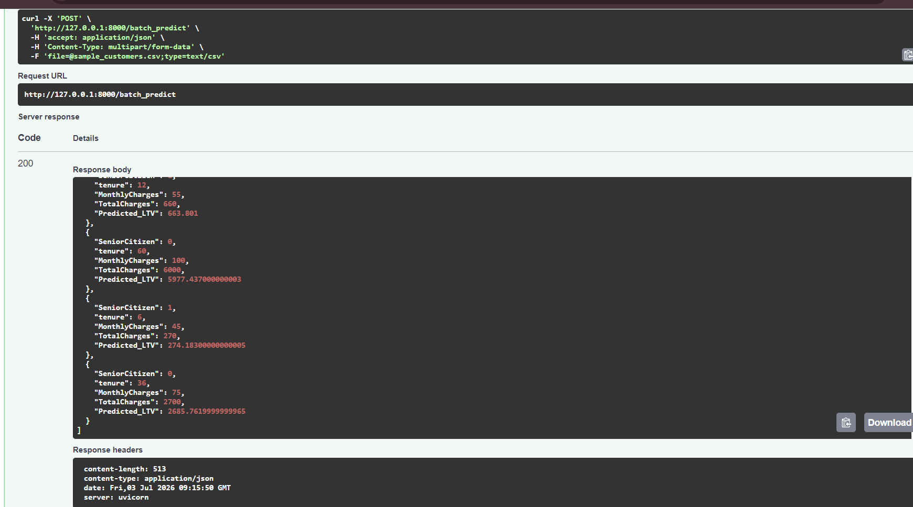
Figure 5: Batch Customer LTV Prediction using CSV Upload

Technologies Used
- Python
- Pandas
- NumPy
- Scikit-learn
- FastAPI
- Uvicorn
- Joblib

Files Created
scripts/
└── week 3/
└──01_ltv_preprocessing.py
└── 02_regression_models.py

api/
└── app.py

models/
└── linear_regression.pkl
└── random_forest_regressor.pkl

data/
└── ltv_dataset.csv
└── sample_customers.csv
Outputs
- Created LTV dataset.
- Trained regression models.
- Saved ML models.
- Built REST API.
- Successfully performed:
  - Single customer prediction
  - Batch prediction
- Generated Swagger API documentation.

Learning Outcomes
During Week 3, I learned:
- Regression model development.
- Customer Lifetime Value prediction.
- Model serialization using Joblib.
- REST API development with FastAPI.
- API testing using Swagger UI.
- Batch prediction using CSV files.

Conclusion
Successfully completed the Customer Lifetime Value prediction module by building regression models and deploying them through a FastAPI-based prediction service capable of both single and batch inference.

